- An Introduction to Data Warehousing
Data Warehousing is a technology that collects, stores, and manages large volumes of historical data from various sources to support business analysis and decision-making. Unlike operational databases, data warehouses are optimized for reading and analyzing data rather than transactional processing.
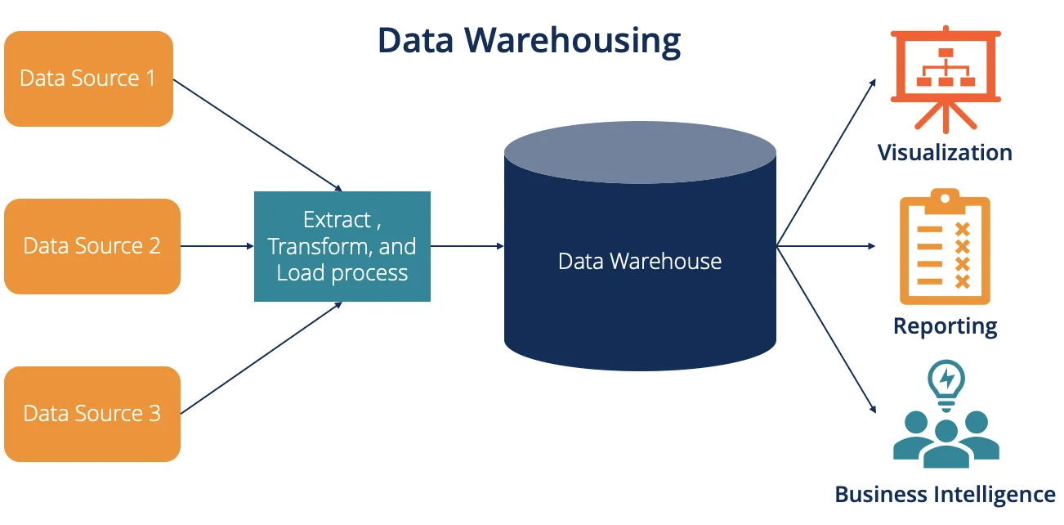

- Purpose of Data Warehouse
Here are the 3 main purposes of a Data Warehouse:
- Centralized Data Storage:
Integrates data from multiple sources into a single, unified repository.
- Support for Decision Making:
Provides accurate, historical, and analytical data to help businesses make informed decisions.
- Efficient Data Analysis & Reporting:
Enables fast, complex queries, trend analysis, and business intelligence reporting.
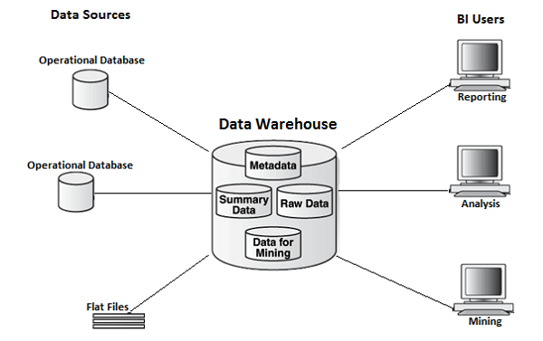
- Data Warehouse Architecture
Typically includes three layers:
- Data Source Layer (operational DBs, flat files)
- Data Staging Layer (ETL process)
- Presentation Layer (data marts, OLAP cubes, reporting tools)

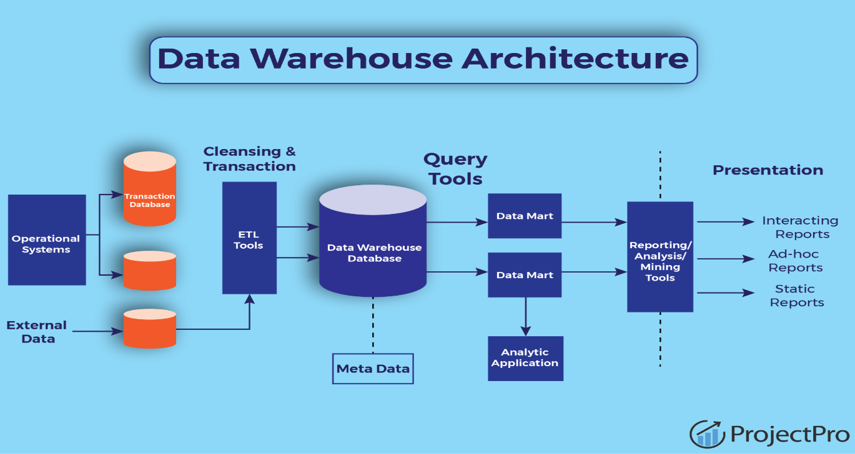

- Operational Data Store (ODS)
An ODS is an intermediate layer between operational systems and a data warehouse. It stores current operational data in a central database for short-term decisions and is often updated in real-time.

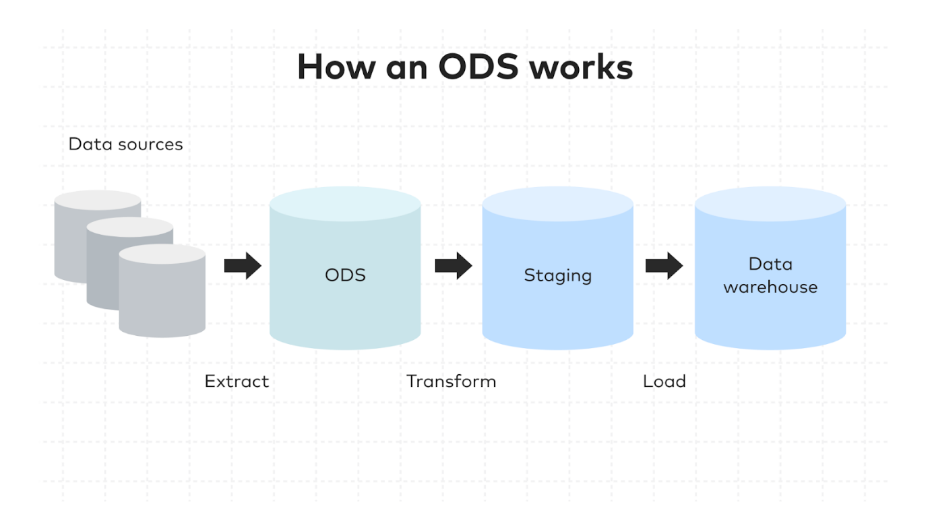

- OLTP vs Warehouse Applications
OLTP (Online Transaction Processing): Optimized for quick insert/update/delete operations. Used for day-to-day operations.
Data Warehouse: Optimized for read-heavy operations, complex queries, and data analysis.
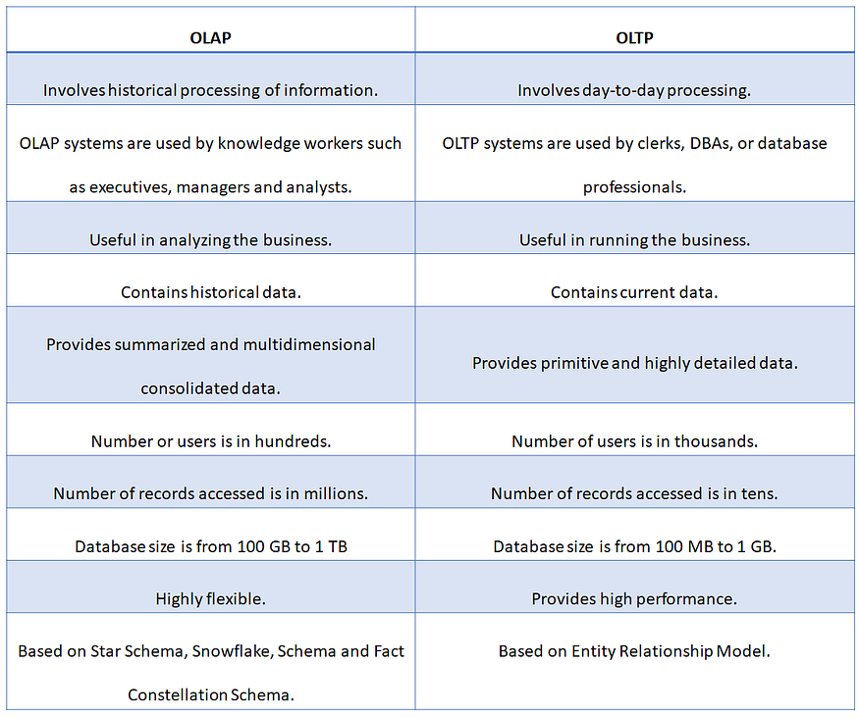
- Data Marts
A data mart is a subset of a data warehouse focused on a specific business line or team (e.g., sales, HR). It provides quicker access and is easier to maintain for specific needs.

- Data Marts vs Data Warehouses
Data Warehouse: Enterprise-wide, contains integrated data from all sources.
Data Mart: Department-specific, contains focused datasets.
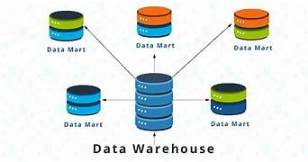

- Data Warehouse Life Cycle
